***NUTRITION***

Human beings eat food from other animals and plants. Food contains the nutrients we need to live and grow. There are 4 systems that take part in their nutrition :

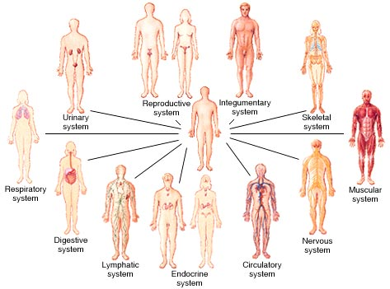

1-Digestive system

2-Respiratory system

3-Circulatory system

4-Excretory system

Our digestive system helps us to get the nutrients we need from food, The main parts are the **mouth**, the **stomach**, the **esophagus**, the **small** and the **large intestine**.

Our respiratory system helps us to breathe in (oxygen) and breathe out (carbon dioxide). The main parts are the **nostrils**, the **windpipe**, the **bronchi** and the **lungs**.

Our circulatory system carries nutrients from the food we eat and oxygen from the air we breathe around the body. The main parts are the **heart,** the **blood** and the **blood vessels**.

Our excretory system helps our body to get rid of excess water and waste products. The main parts are the **kidneys**, the **bladder**, the **ureters** and the **urethra**.